# How to Use a Chalk Marker

Using a chalk marker is pretty easy for anyone. For activating a fresh new chalk marker first, you need to hold it at a 45-degree angle. More like a crossway you need to grab it.

The next step includes giving an even shake to the marker, and it’s ready to use. It’s not okay to shake too much, this might be an issue while writing.

## How to Use a Chalk Marker?

The procedure for activating a chalk marker is just to hold it in a diagonal position. And give a moderate shake so the inside ink gets free if it was clotted. Of course, make sure your pens’ lid is off.

After it is ready to use, open up the lid and keep the tip on the paper and give a gentle push on the paper with the tip. Make sure the pressure is not too high, else it might leak more ink than needed. Also, it might cause the nib to break for excessive force.

Chalk markers are one of the most hyped stationery items and all kinds of surfaces are appropriate for it to act on. Non-porous surfaces like metals, glasses, slate chalkboards, porcelain surfaces, and any other sealed area is just the spot it will show its supremacy.

Some surfaces are not compatible with the chalk markers, i.e., painted walls painted MDF boards and any other kind of surface that has the possibility of absorbing the ink hues.

The non-porous surfaces are always encouraged to be clear and clean. If there is any kind of disturbance in the surface area of working the output will not be satisfactory. Also, the ink takes time to dry so, if you are facing an uneven work arena there is an option for you to correct it.

## How to erase the chalk marker?

If your surface is a non porous one then it’s pretty easy to erase the inks. If your marker ink is still wet and you have a change in the plan, you can simply take any dry cloth and clean it up.

Better finish

For a better finishing of removing the color coat, you can use microfiber cloth pieces. Again, if your work is dried and you need an edit or redo the work, there are still ways. Here’s a link to redirect to the cleaning process, <https://www.youtube.com/watch?v=0tQk3HF1H_E>

Users Exp.

From some users' experience, it is clear you can use any kind of mild glass cleaner to make the surface crystal fresh. Also, a homemade element remedy can be like 1 cup of white vinegar with 4 cups of water mixture for the cleaning process.

So, these are the easiest ways to make your working area clear again. Even though chalk markers give permanent finishing yet in need of making a change there are possible ways.

## How to make chalk marker permanent on glass?

To make your chalk marker outcomes permanent you’ll need to lock it with a coating spray. When you have made your work done with the markers and it’s dried take a wall paint spray which will not disturb the marker color. Spray it from at least a 10-inch distance.

The microparticles lock the chalk-marker to be permanent and later it’s not removable. That is how to make a chalk marker work sealed on glass or any non-porous surface.

## Chalk markers for chalkboard painted walls

It is usually not preferable to use chalk markers other than no-porous surfaces. But if you’re still willing to use them on a painted wall you can select the liquid chalk marker pens. They are easily removable as well.

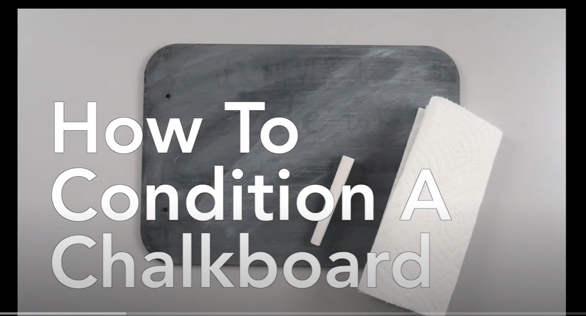

<https://www.youtube.com/watch?v=BS6BZQeOY_g> check this video how to prepare a chalkboard.

And also the below video for it’s removable facility from a chalkboard painted walls.

<https://www.youtube.com/watch?v=ff8yFDHBCis>

## How to use liquid chalk?

Liquid chalk markers are pen-like markers and are very convenient to use. The usage procedure is easy, just shake it in a diagonal position and you’re ready to use it.

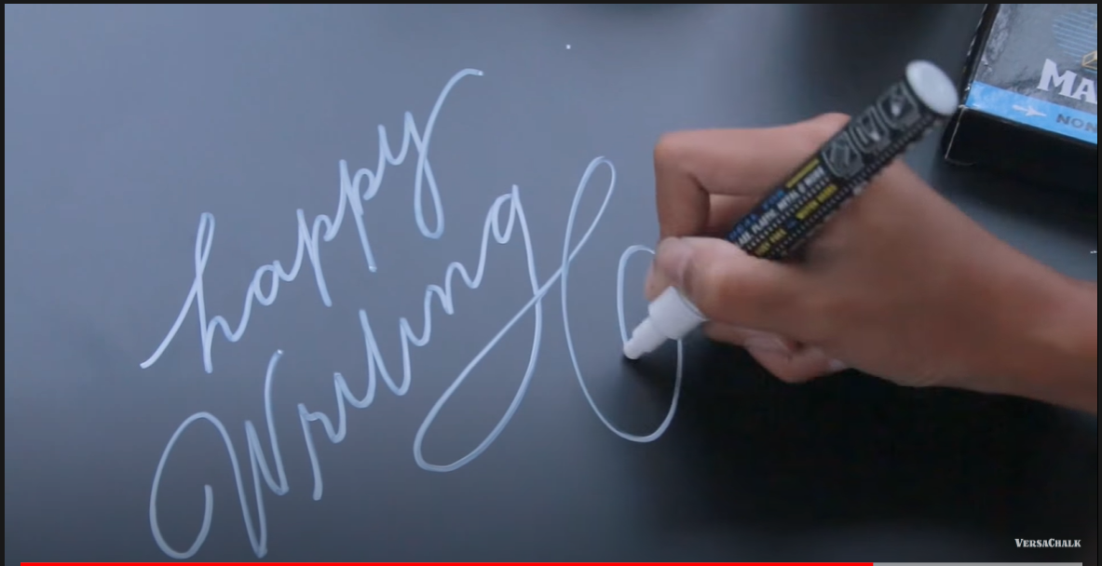

Usually, it takes 20-30 pumps to finish the work, press the tip with the solid surface and the ink to do the magic along with your idea’s visualization. Here’s a demonstration nicely shown <https://www.youtube.com/watch?v=Yyu5xUfYpek>

## FAQ

Are the markers pigmented enough?

Yes, the chalk markers are bright and pigmented. They come in 15 colors usually.

Are they smooth to use?

Yes, the markers give pretty smooth finishing when it comes to a non-porous base. Other than those kinds of surfaces, the rest absorbs and that might deform the designs you work on. Usually, the markers include oil-type inks.

## Conclusion

Using a chalk marker is not a hard job at all, all you need to keep in mind is what kind of surface you are applying it on. All those surfaces that don’t do the absorption work will collaborate with the markers nicely.

Also, not to mention that, if you think the ink is not dropping just shake it a bit and keep on pumping until you finish drawing or writing. This might seem tedious but this works on the proper distribution of perfect hued ink.